Accessibility Issues in HCI

What is Accessibility in HCI?  
Accessibility is the concept of whether a product or service can be used by everyone – however they encounter it (InteractionDesign.org, 2002). You would normally associate accessibility with enabling people with disabilities and the elderly to use interfaces/devices with more ease. However, accessible designs benefit everyone, of all ages and abilities. Accessible features don’t only benefit the elderly or disabled. Although the feature may be targeted to aid a particular group of people, it may actually prove beneficial for others too. For example, video captions are made to help people with hearing impairments however it also proves useful when people need to listen to a video on mute (InteractionDesign.org, 2002). Situations such as these could arise at any time and therefore such features are not just specifically for one particular demographic. If a product is created for all abilities, then anyone will be able to enjoy that product and use it with ease.

Is Accessibility the Same as Usability?

Although similar, usability is defined as a measure of how a user can effectively, efficiently and satisfactorily complete a defined task (InteractionDesign.org, 2002). Having a usable interface means that the interface straightforward to use and the users can carry out their desired task with ease.

Whereas accessibility focusses on ‘whether all users are able to access an equivalent user experience, however they encounter a product or service’ (InteractionDesign.org, 2002). A product which is accessible, ensures that no one is excluded from using that product. Specifically, people with disabilities.

The two concepts are very similar, and many consider accessibility a part of usability.

Making Interfaces Accessible for All

A quote by Billy Gregory, a senior accessibility engineer, “When UX doesn’t consider ALL users, shouldn’t it be known as “SOME User Experience” or… SUX?”. Gregory emphasises the importance of inclusion when creating an interface. The play on the abbreviation for some user experience (SUX) depicts his feelings towards what good user experience is.

Around 15% of the world’s population live with some form of disability (WHO.org 2011). If the design is not accessible, then a large portion of the population is overlooked.

It is common for developers to dismiss accessibility (Taylor, 2019) as they assume that the target demographic using their particular interface won’t require accessibility features. They also fear that, implementing these features will take up more time in an already busy project schedule (Krugg, 2014).

Designers also often try to steer away from thinking about accessibility, as they have a preconception that design for disabled people is different from design for everyone else (Krugg, 2014).

However, developers and designers should not make such assumptions as it excludes potential users which is not only ethically incorrect, but it can also improve the company’s image. In addition to this, there will be some “legislative stick” (Krugg,2014) that the organisations will have to face if the interfaces are not made accessible.

Approaches to target Accessibility Issues

Developers should take into consideration the possible accessibility issues which may occur for individuals with disabilities.

Types of disabilities include:

* Visual (e.g., colour blindness)
* Mobility
* Auditory/ Hearing impairment
* Learning (e.g., dyslexia, autism)

There are several features which can be implemented, they vary depending on the disability.

Visual Impairments

Small adjustments such as altering text size (make it larger/ able to zoom) or ensuring that the webpage works well with screen readers can make a difference for people who have visual impairments. In addition to this, ssing ALT tags on images so that screen readers can describe what the image depicts is also beneficial. Placement of items also helps users with visual impairments as they will be able to navigate across the interface with more ease.

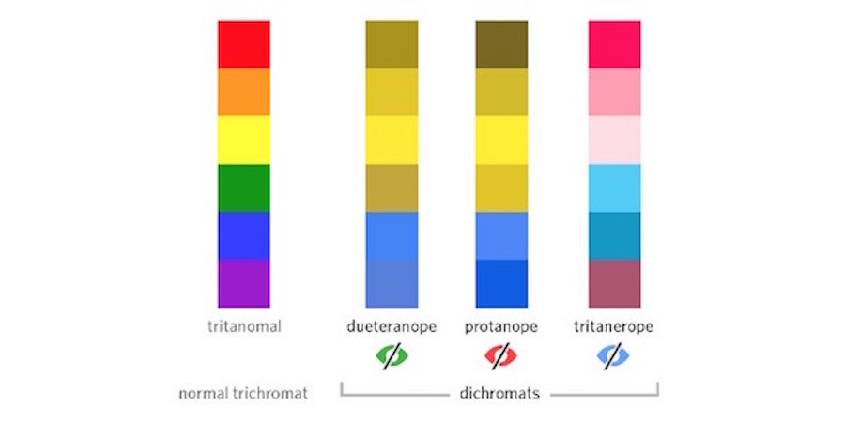

People with colour blindness find it difficult to distinguish between particular colours, therefore the use of contrasting colours on the text and background enable these users to view information with no issues. The image on the right shows how people with different forms of colour blindness view certain colours. Avoiding colour combinations such as blue & purple and red & green as they are a ‘potential nightmare’ (Collinge, 2017) for colour blind users.

Image 1 (Collinge, 2017) showing how red, green and blue colour-blind individuals see regular colours (normal vision)

Altering the colour may not be sufficient when trying to highlight significant information for someone with visual impairments. The use of textures as well as colour can help with making important information stand out more. Pictorial representations of data such as graphs or diagrams can be harder to read when only different colours are used to distinguish the data (Stanley, 2018). Printing a graph out in black and white and seeing if everything is still easily distinguishable due to the adding of textures is a good way in ensuring users with colour blindness can still interpret the data correctly.

Mobility Impairments

If an individual has mobility issues, then having large buttons so that precision is not as important, or haptic feedback so that the user knows when they have clicked on something is particularly useful. There are also some devices which have been created in order to assist people whilst traversing through webpages or any interfaces for that matter. Some examples are:

* Mouth Sticks – these are thin sticks with a rubber end. It is placed into the individuals mouth and then they can use the stick to click on buttons etc…
* Eye-Gaze – this uses the tracking of a user’s eye movement which acts as a mouse so that users can interact with devices without the need of a physical mouse or any actual movement.
* Single Switch Press – For users with very limited mobility, this switch would work so that whenever the user hits/clicks the switch, the software will interpret these clicks which enables users to navigate though webpages.

(Vejalla, 2020)

Hearing Impairments

For users with hearing impairments, having captions or equivalent text transcripts (Cavender, 2007) for when there are videos present on the webpage are needed. However, this does not only benefit people with auditory issues, it also is useful for people who are unable to listen to a video due to their environment (i.e., if they’re in a library and don’t have headphones).

Learning Disabilities

For people with learning disabilities such as Dyslexia, changing the font style can be extremely useful as some fonts are more difficult to read than others. Webpages should also have the option to alter the typography of the text. Typography involves the adjusting of text to make it more readable. It involves changing the line spacing, character spacing, font size and font style. Making the line spacing and character spacing wider, people with dyslexia will find it easier to read the text (Vejalla, 2020). Furthermore, instead of text base alerts, making them auditory alerts will be more time efficient for the user as they won’t have to figure out what the alert is for (Vejalla,2020).

Keyboard Accessibility

This is an integral part of accessibility as a wide variety of disabilities depend on the keyboard to access required content.

Users with mobility issues often find it difficult to use a mouse and therefore they use the keyboard online to navigate through the website. It is a general guideline for designers to ensure that their websites can be accessible through just the keyboard in order to accommodate for people with physical impairments.

Even users without any disabilities find using the keyboard to navigate through a webpage useful. For example, using the tab key to iterate through a form on a webpage until you reach the desired input fields is sometimes more efficient than to use the mouse (Stanley,2018).

The order of elements within the website should be consistent, as when using the tab key to go through the webpage, it should follow a logical order. Typically left to right and top to bottom makes the most sense (Stanley, 2018). In addition to this, the enter key is usually equivalent to clicking a button. To check if the website is keyboard accessible you can use both the tab and enter key to see if it flows in a coherent order and you can click on particular elements (with the enter key).

One important factor which needs to be considered when designing a webpage, is that it should not be too busy. If there are several buttons and long menus on the webpage then it may be taxing for people with mobility disabilities. Keeping the website clear and simple is best for everyone.

Image 2 – (Lynda.com, 2021) Two images, both showing the layout of an email system

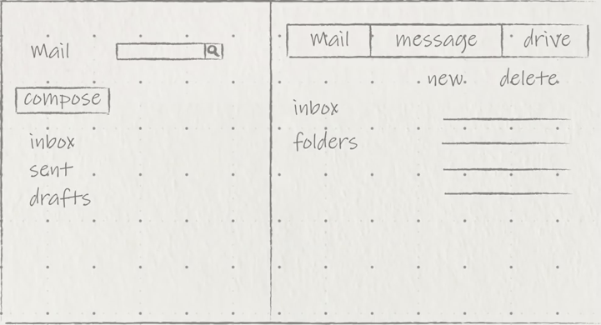Fitts law

Fitts law states “that the amount of time required for a person to move a pointer (e.g., mouse cursor) to a target area is a function of the distance to the target divided by the size of the target (InteractionDesign.org, 2002). If the target is smaller and further away from the user then it is slower to click than a target which is larger and closer to the user.

There are specific ways in which you can position items on a webpage to make it easier for the user to select. Placing similar items together in one place (image 2 – left image) rather than spread out across the page (image 2, right image), is a lot clearer and efficient for users.

As well as placement, sizing of the boxes is important. The larger the target size, the shorter the distance between the users starting point and the target and the quicker it is to select it. Additionally, tasks which are executed more often should correspond to a larger button, but this shouldn’t harm the consistency of the interface (Barreiro, 2021).

Designers have to take these factors into consideration and try to create objects which is fairly large but should not look out of place. In addition to this, keeping objects of the same ‘sequence chain’ (InteractionDesign.org, 2002) close together is time effective.

Conclusion

The practice of making a website accessible does not only benefit people with disabilities, but it can be useful for any “fully able-bodied” user (InteractionDesign.org, 2002) due to distractions/their environment etc…

There should be no discrimination between people with and without disabilities which is why nowadays it is not only morally correct but also legally correct to make interfaces accessible.

Ensuring that users who do have impairments can also complete their desired tasks as comfortably as anyone else should be at the forefront of what to consider when designing an interface.

With the tools and techniques, we have available to us today there is no excuse for creating the optimal user experience for everyone.